* **Working with AutoCompleteTextView, spinner, ListView**

**Xml file:**

* **AutoCompleteTextview:**

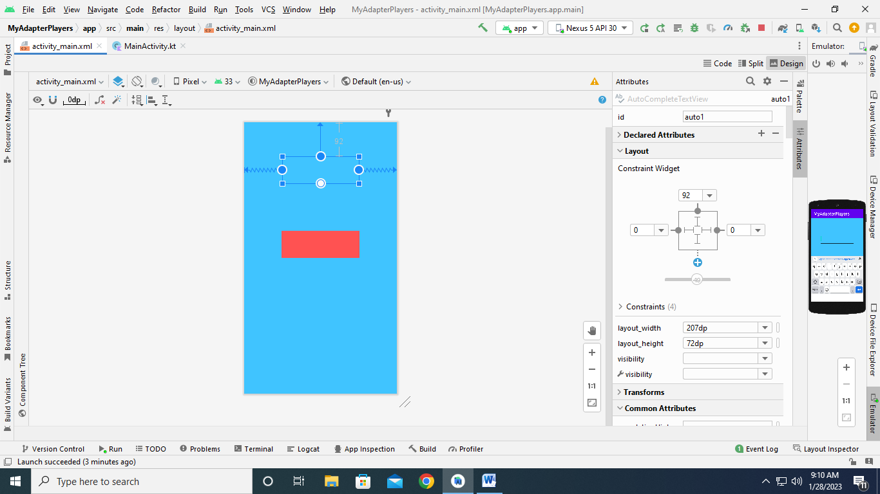

* **Spinner:**

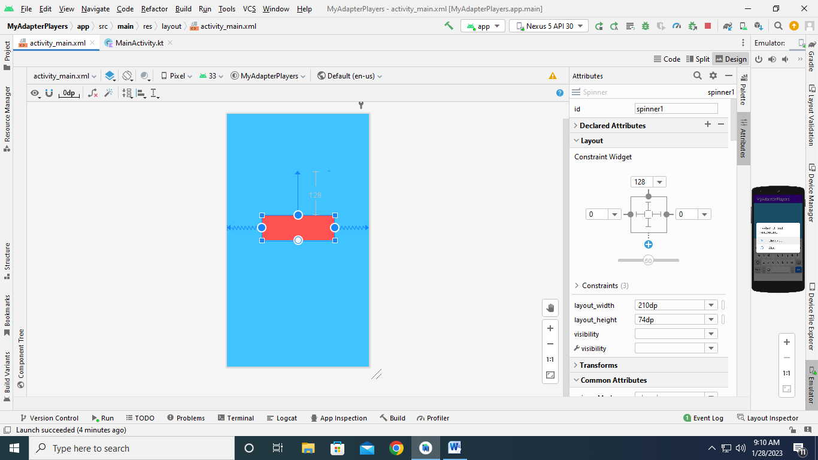

* **MainActivityfile code:**

package com.example.myadapterplayers

import android.appcompat.app.AppCompatActivity

import android.os.Bundle

import android.widget.*

class MainActivity : AppCompatActivity() {

override fun onCreate(savedInstanceState: Bundle?) {

super.onCreate(sacedInstanceState)

setContenView(R.layout.activity_main)

var players=arrayOf(“Rohit Sharma”,”Shubhman Gill”,”Hardik Pandy”,”Krunal Pandya”)

var adapter:ArrayAdapter<String>

var autotext: AutoCompleteTextView = findViewById(R.id.auto1)

autotext.threshold=2;

autotext.setAdapter(adapter)

var spin: Spinner=findViewById(R.id.spinner1)

spin.adapter=adapter;

}

}

1. **App launch:**

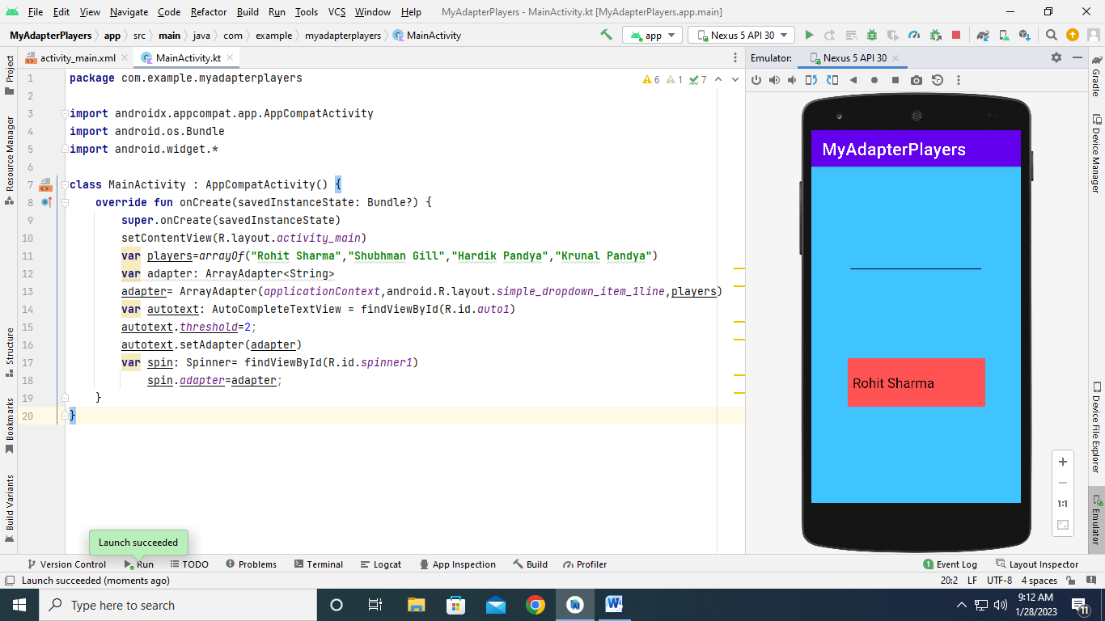

* **AutoCompleteTextView suggestion after insert initial letter:**

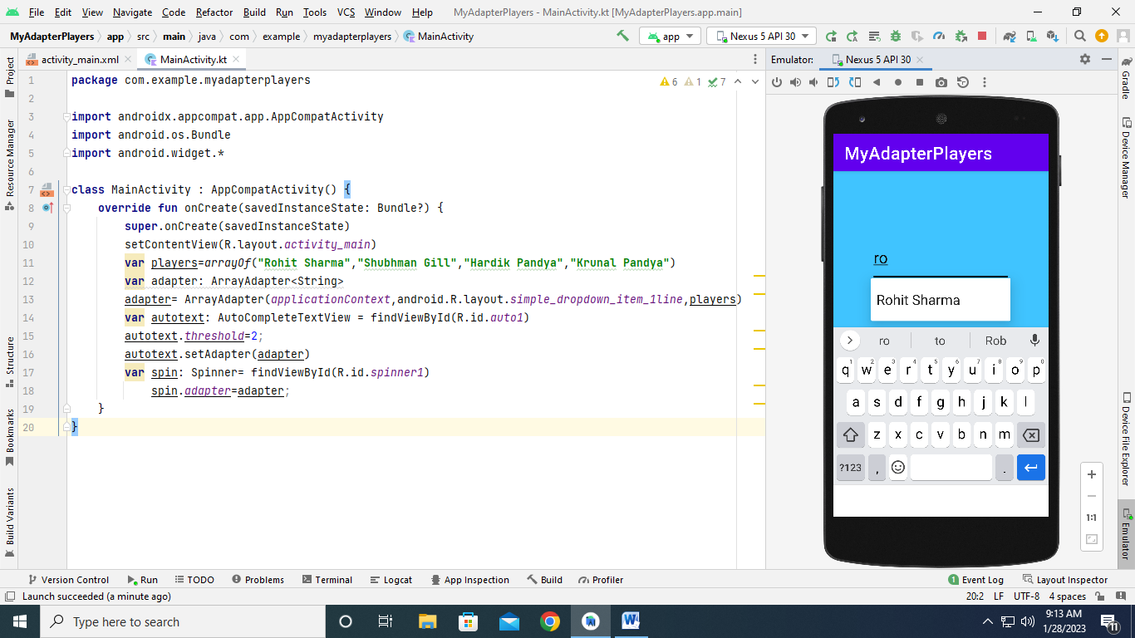

* **All suggestion in spinner container:**

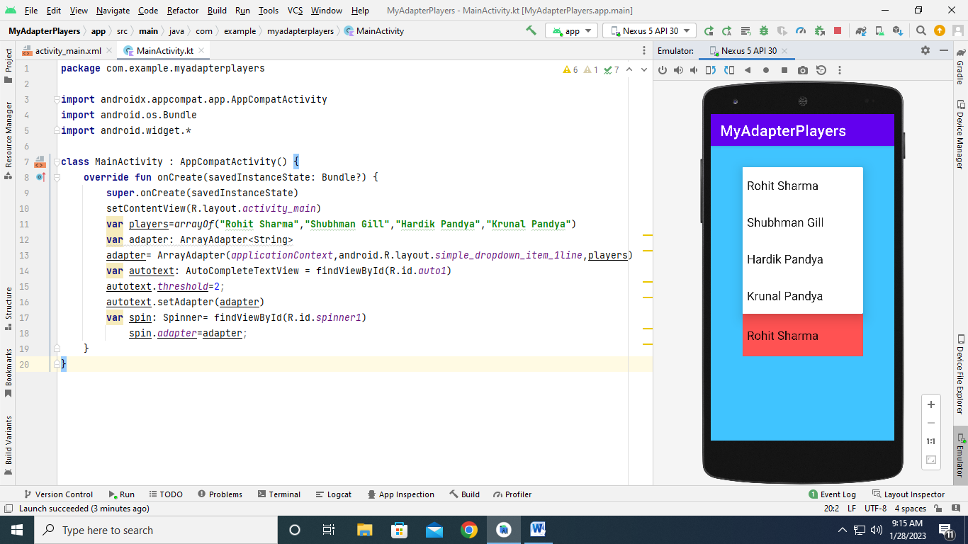

* **ListView MainActivity.kt code:**

package com.example.listview2  
  
import androidx.appcompat.app.AppCompatActivity  
import android.os.Bundle  
import android.view.View  
import android.widget.AdapterView  
import android.widget.ArrayAdapter  
import android.widget.ListView  
import android.widget.Toast  
  
class MainActivity : AppCompatActivity(), AdapterView.OnItemClickListener {  
 override fun onCreate(savedInstanceState: Bundle?) {  
 super.onCreate(savedInstanceState)  
 setContentView(R.layout.*activity_main*)  
  
 var list1: ListView? = null  
 var adapter: ArrayAdapter<String>? = null  
  
 var itemlist:Array<String>  
 itemlist = *resources*.getStringArray((R.array.*programming_lang*))

list1 = findViewById(R.id.*l1*)  
 adapter = ArrayAdapter(this, android.R.layout.*simple_list_item_1*, itemlist)  
 list1.*adapter* = adapter  
  
 list1.*onItemClickListener* = this  
  
  
 }  
  
 override fun onItemClick(p0: AdapterView<*>?, p1: View?, p2: Int, p3: Long) {  
 var item = p0?.getItemAtPosition(p2).*toString*()  
 Toast.makeText(this, "Selected language: " + item, Toast.*LENGTH_LONG*).show()  
 }  
  
}

* **App launch:**

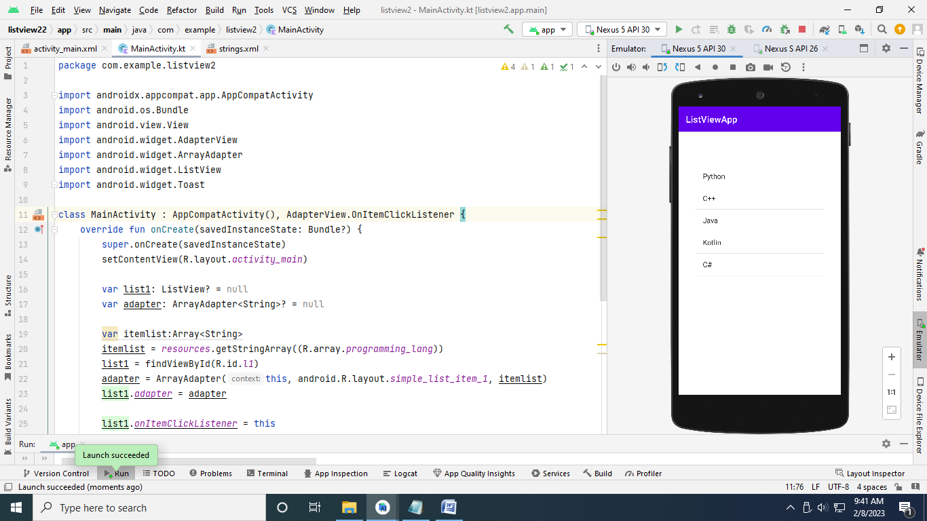

* **Xml file:**

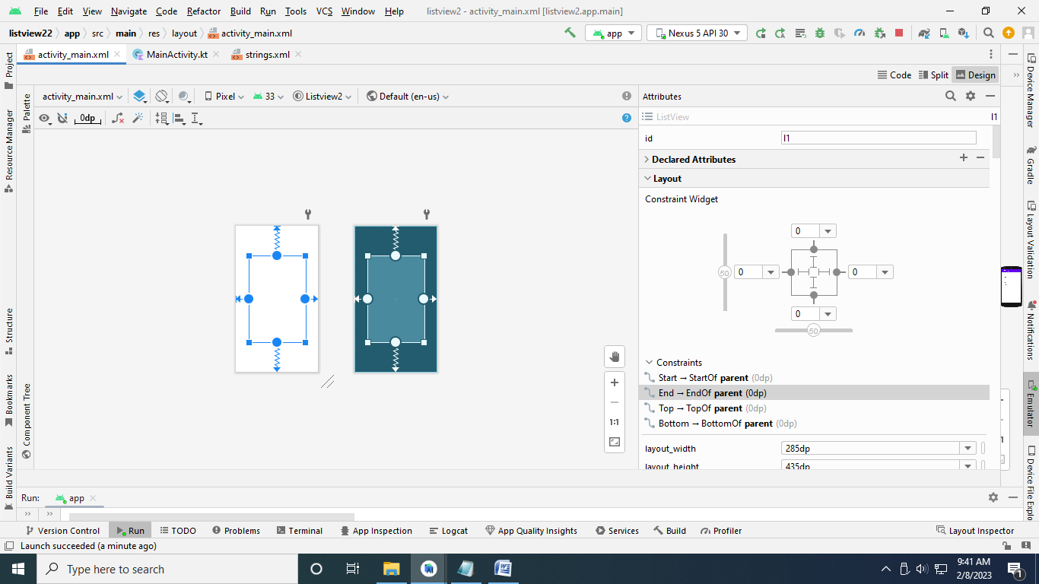

**String.xml:**

<resources>  
 <string name="app_name">ListViewApp</string>  
 <string-array name="programming_lang">  
 <item>Python</item>  
 <item>C++</item>  
 <item>Java</item>  
 <item>Kotlin</item>  
 <item>C#</item>  
 </string-array>  
</resources>

**Emulator:**

